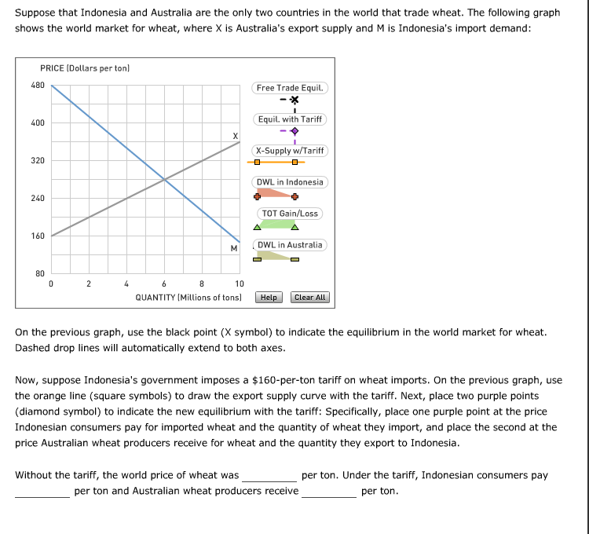

WHEAT WAS

280
380
220
440

iNONESIAN CONSUMERS PAY

380
220
280
440

aUSTRALLIAN WHEAT PRODUCERS RECEIVE

440
380
220
280
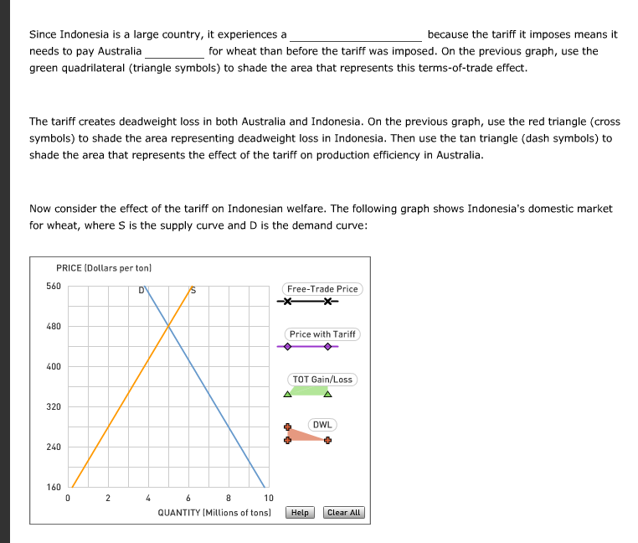
iT EXPERIENCES A

TERMS OF TRADE GAIN
TERMS OF TRADE LOSS
DEADWEIGHT LOSS

NEED TO PAY AUSTRALIA

LESS
MORE
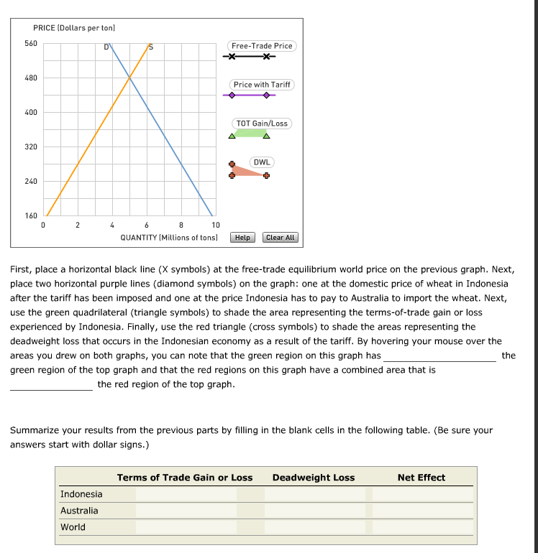

THIS GRAPH HAS

A SMALLER AREA THAN
A LARGER AREA THAN
THE SAME AREA AS

A COMBINED AREA THAT IS

THE SAME AS
SMALLER THAN
LARGER THAN

